52.pielikums
Ministru kabineta
2013.gada 19.marta
noteikumiem Nr.154

Kandavas novada administratīvās teritorijas robežas apraksts

2012.gada 1.oktobris
(robežas apraksta sagatavošanas datums)

Nr.  p.k. | Tās zemes vienības kadastra apzīmējums, pa kuru noteikta administratīvās teritorijas robeža | Robežojošās administratīvās teritorijas nosaukums
 | 90620030032 | Talsu novads
 | 90620030002 | Talsu novads
 | 90620030039 | Talsu novads
 | 90620030037 | Talsu novads
 | 90620030015 | Talsu novads
 | 90620010006 | Talsu novads
 | 90620010047 | Talsu novads
 | 90620010057 | Talsu novads
 | 90620010037 | Talsu novads
 | 90620010033 | Talsu novads
 | 90620010038 | Talsu novads
 | 90620010048 | Talsu novads
 | 90620010012 | Talsu novads
 | 90620010043 | Talsu novads
 | 90620010007 | Talsu novads
 | 90620010046 | Talsu novads
 | 90620010041 | Talsu novads
 | 90620010051 | Talsu novads
 | 90620010055 | Talsu novads
 | 90620010023 | Talsu novads
 | 90620020066 | Talsu novads
 | 90620020053 | Talsu novads
 | 90620020014 | Talsu novads
 | 90620020071 | Talsu novads
 | 90620020029 | Talsu novads
 | 90620020030 | Talsu novads
 | 90620020038 | Talsu novads
 | 90440010065 | Talsu novads
 | 90440010009 | Talsu novads
 | 90440010052 | Talsu novads
 | 90440010028 | Talsu novads
 | 90440010037 | Talsu novads
 | 90440010051 | Talsu novads
 | 90440010042 | Talsu novads
 | 90440010020 | Talsu novads
 | 90440010007 | Talsu novads
 | 90440010033 | Talsu novads
 | 90440020062 | Talsu novads
 | 90440020027 | Talsu novads
 | 90440020108 | Talsu novads
 | 90440020009 | Talsu novads
 | 90440020025 | Talsu novads
 | 90440020030 | Talsu novads
 | 90440020032 | Talsu novads
 | 90440020028 | Talsu novads
 | 90440020070 | Talsu novads
 | 90440020053 | Talsu novads
 | 90440020106 | Talsu novads
 | 90440020125 | Talsu novads
 | 90440020047 | Talsu novads
 | 90440020002 | Talsu novads
 | 90440020059 | Talsu novads
 | 90440020046 | Talsu novads
 | 90440020059 | Talsu novads
 | 90440020133 | Talsu novads
 | 90440030044 | Talsu novads
 | 90440030011 | Talsu novads
 | 90440030039 | Talsu novads
 | 90440040076 | Talsu novads
 | 90440040028 | Talsu novads
 | 90440040030 | Talsu novads
 | 90440040066 | Talsu novads
 | 90440040053 | Talsu novads  Tukuma novads
 | 90440040015 | Tukuma novads
 | 90440040001 | Tukuma novads
 | 90440040068 | Tukuma novads
 | 90440040002 | Tukuma novads
 | 90440040011 | Tukuma novads
 | 90440040016 | Tukuma novads
 | 90440040009 | Tukuma novads
 | 90440040068 | Tukuma novads
 | 90440040041 | Tukuma novads
 | 90440050113 | Tukuma novads
 | 90440050145 | Tukuma novads
 | 90440050114 | Tukuma novads
 | 90440050006 | Tukuma novads
 | 90440050111 | Tukuma novads
 | 90440050025 | Tukuma novads
 | 90440050022 | Tukuma novads
 | 90440050111 | Tukuma novads
 | 90440050164 | Tukuma novads
 | 90620070014 | Tukuma novads
 | 90620070022 | Tukuma novads
 | 90620070045 | Tukuma novads
 | 90620070017 | Tukuma novads
 | 90620120008 | Tukuma novads
 | 90620120031 | Tukuma novads
 | 90620120032 | Tukuma novads
 | 90620120021 | Tukuma novads
 | 90620120013 | Tukuma novads
 | 90620120023 | Tukuma novads
 | 90620120024 | Tukuma novads
 | 90620160100 | Tukuma novads
 | 90620160042 | Tukuma novads
 | 90620160007 | Tukuma novads
 | 90620160097 | Tukuma novads
 | 90620160062 | Tukuma novads
 | 90620160098 | Tukuma novads
 | 90620160076 | Tukuma novads
 | 90620160098 | Tukuma novads
 | 90620160102 | Tukuma novads
 | 90620160096 | Tukuma novads
 | 90620160077 | Tukuma novads
 | 90620160096 | Tukuma novads
 | 90620160005 | Tukuma novads
 | 90620160096 | Tukuma novads
 | 90620160095 | Tukuma novads
 | 90620160101 | Tukuma novads
 | 90620160093 | Tukuma novads
 | 90620160011 | Tukuma novads
 | 90620160093 | Tukuma novads
 | 90620150172 | Tukuma novads
 | 90620150138 | Tukuma novads
 | 90620150071 | Tukuma novads
 | 90620150068 | Tukuma novads
 | 90940010302 | Tukuma novads
 | 90940010307 | Tukuma novads
 | 90940010099 | Tukuma novads
 | 90940010352 | Tukuma novads
 | 90940010102 | Tukuma novads
 | 90940010283 | Tukuma novads
 | 90940010303 | Tukuma novads
 | 90940010206 | Tukuma novads
 | 90940010204 | Tukuma novads
 | 90940010351 | Tukuma novads
 | 90940010208 | Tukuma novads
 | 90940010205 | Tukuma novads
 | 90940010326 | Tukuma novads
 | 90940010044 | Tukuma novads
 | 90940010049 | Tukuma novads
 | 90940010063 | Tukuma novads
 | 90940030082 | Tukuma novads
 | 90940030006 | Tukuma novads
 | 90940030081 | Tukuma novads
 | 90940030011 | Tukuma novads
 | 90940030038 | Tukuma novads
 | 90940030031 | Tukuma novads
 | 90940030026 | Tukuma novads
 | 90940030057 | Tukuma novads
 | 90940030124 | Tukuma novads
 | 90940030022 | Tukuma novads
 | 90940030179 | Tukuma novads
 | 90940030072 | Tukuma novads
 | 90940030137 | Tukuma novads
 | 90940030073 | Tukuma novads
 | 90940030075 | Tukuma novads
 | 90940030126 | Tukuma novads
 | 90940030003 | Tukuma novads
 | 90940030029 | Tukuma novads
 | 90940030093 | Tukuma novads
 | 90940030153 | Tukuma novads  Jaunpils novads
 | 90940030196 | Jaunpils novads
 | 90940030344 | Jaunpils novads
 | 90940030178 | Jaunpils novads
 | 90940030345 | Jaunpils novads
 | 90940030151 | Jaunpils novads
 | 90940030097 | Jaunpils novads
 | 90920040071 | Jaunpils novads
 | 90920040059 | Jaunpils novads
 | 90920040089 | Jaunpils novads
 | 90920040060 | Jaunpils novads
 | 90920040045 | Jaunpils novads
 | 90920040085 | Jaunpils novads
 | 90920040021 | Jaunpils novads
 | 90920040055 | Jaunpils novads
 | 90920040056 | Jaunpils novads
 | 90920040043 | Jaunpils novads
 | 90920040138 | Jaunpils novads
 | 90920040096 | Jaunpils novads
 | 90920040024 | Jaunpils novads
 | 90920040040 | Jaunpils novads
 | 90920040087 | Jaunpils novads
 | 90920040022 | Jaunpils novads
 | 90920040029 | Jaunpils novads
 | 90920040050 | Jaunpils novads  Brocēnu novads
 | 90920020030 | Brocēnu novads
 | 90920020054 | Brocēnu novads
 | 90920020001 | Brocēnu novads
 | 90920020064 | Brocēnu novads
 | 90920020050 | Brocēnu novads
 | 90920020027 | Brocēnu novads
 | 90920020080 | Brocēnu novads
 | 90920020040 | Brocēnu novads
 | 90920020066 | Brocēnu novads
 | 90920020053 | Brocēnu novads
 | 90920020034 | Brocēnu novads
 | 90920020036 | Brocēnu novads
 | 90920020058 | Brocēnu novads
 | 90920020052 | Brocēnu novads
 | 90920020085 | Brocēnu novads
 | 90920020051 | Brocēnu novads
 | 90920020056 | Brocēnu novads
 | 90920020051 | Brocēnu novads
 | 90920020081 | Brocēnu novads
 | 90920020023 | Brocēnu novads
 | 90920020072 | Brocēnu novads
 | 90920020018 | Brocēnu novads
 | 90920020041 | Brocēnu novads
 | 90920020019 | Brocēnu novads
 | 90920020055 | Brocēnu novads
 | 90920020073 | Brocēnu novads
 | 90880080036 | Brocēnu novads
 | 90880070038 | Brocēnu novads
 | 90880070093 | Brocēnu novads
 | 90880070024 | Brocēnu novads
 | 90880070007 | Brocēnu novads
 | 90880070062 | Brocēnu novads
 | 90880070084 | Brocēnu novads
 | 90880070092 | Brocēnu novads  Saldus novads
 | 90880070101 | Saldus novads
 | 90880070094 | Saldus novads
 | 90880070001 | Saldus novads
 | 90880070065 | Saldus novads
 | 90880070063 | Saldus novads
 | 90880070104 | Saldus novads
 | 90880070100 | Saldus novads
 | 90880010326 | Saldus novads
 | 90880010052 | Saldus novads
 | 90880010326 | Saldus novads
 | 90880010130 | Saldus novads
 | 90880010326 | Saldus novads
 | 90880010129 | Saldus novads
 | 90880010326 | Saldus novads
 | 90880010290 | Saldus novads
 | 90880010326 | Saldus novads
 | 90880010292 | Saldus novads
 | 90880010331 | Saldus novads
 | 90880010337 | Saldus novads
 | 90880010331 | Saldus novads
 | 90880010336 | Saldus novads
 | 90880010241 | Saldus novads
 | 90880010326 | Saldus novads
 | 90880010044 | Saldus novads
 | 90880010051 | Saldus novads
 | 90880010242 | Saldus novads
 | 90880010366 | Saldus novads
 | 90880010298 | Saldus novads
 | 90880010182 | Saldus novads
 | 90880010167 | Saldus novads
 | 90880010354 | Saldus novads
 | 90880010195 | Saldus novads
 | 90880010021 | Saldus novads
 | 90880010319 | Saldus novads
 | 90880010032 | Saldus novads
 | 90880010219 | Saldus novads
 | 90880010328 | Saldus novads
 | 90880010318 | Saldus novads
 | 90880010221 | Saldus novads
 | 90880010223 | Saldus novads
 | 90880010225 | Saldus novads
 | 90880010324 | Saldus novads  Kuldīgas novads
 | 90880010364 | Kuldīgas novads
 | 90700010021 | Kuldīgas novads
 | 90700010020 | Kuldīgas novads
 | 90700010031 | Kuldīgas novads
 | 90700010033 | Kuldīgas novads
 | 90700010018 | Kuldīgas novads
 | 90700010050 | Kuldīgas novads
 | 90700010059 | Kuldīgas novads
 | 90700010062 | Kuldīgas novads
 | 90700010025 | Kuldīgas novads
 | 90700010057 | Kuldīgas novads
 | 90700010056 | Kuldīgas novads
 | 90700010040 | Kuldīgas novads
 | 90700010013 | Kuldīgas novads
 | 90700010039 | Kuldīgas novads
 | 90700020022 | Kuldīgas novads
 | 90700020192 | Kuldīgas novads
 | 90700020058 | Kuldīgas novads
 | 90700020052 | Kuldīgas novads
 | 90700020040 | Kuldīgas novads
 | 90700020024 | Kuldīgas novads
 | 90700020020 | Kuldīgas novads
 | 90700020055 | Kuldīgas novads
 | 90700020156 | Kuldīgas novads
 | 90700020003 | Kuldīgas novads
 | 90700020087 | Kuldīgas novads
 | 90700020089 | Kuldīgas novads
 | 90700020085 | Kuldīgas novads  Talsu novads
 | 90700020027 | Talsu novads
 | 90700020007 | Talsu novads
 | 90700020165 | Talsu novads
 | 90700020039 | Talsu novads
 | 90700020033 | Talsu novads
 | 90700020038 | Talsu novads
 | 90700020013 | Talsu novads
 | 90700020108 | Talsu novads
 | 90700020167 | Talsu novads
 | 90700030227 | Talsu novads
 | 90700030322 | Talsu novads
 | 90700030002 | Talsu novads
 | 90700030066 | Talsu novads
 | 90700030123 | Talsu novads
 | 90700030056 | Talsu novads
 | 90700030160 | Talsu novads
 | 90700030055 | Talsu novads
 | 90700030128 | Talsu novads
 | 90700030158 | Talsu novads
 | 90700040062 | Talsu novads
 | 90620130109 | Talsu novads
 | 90620080210 | Talsu novads
 | 90620080036 | Talsu novads
 | 90620080037 | Talsu novads
 | 90620080215 | Talsu novads
 | 90620080230 | Talsu novads
 | 90620080048 | Talsu novads
 | 90620080111 | Talsu novads
 | 90620030058 | Talsu novads
 | 90620030035 | Talsu novads
 | 90620030053 | Talsu novads
 | 90620030020 | Talsu novads
 | 90620030058 | Talsu novads
 | 90620030048 | Talsu novads
 | 90620030011 | Talsu novads
 | 90620030033 | Talsu novads
 | 90620030017 | Talsu novads

Kandavas novada administratīvās teritorijas robežas karte

2012.gada 1.oktobris
(robežas apraksta sagatavošanas datums)

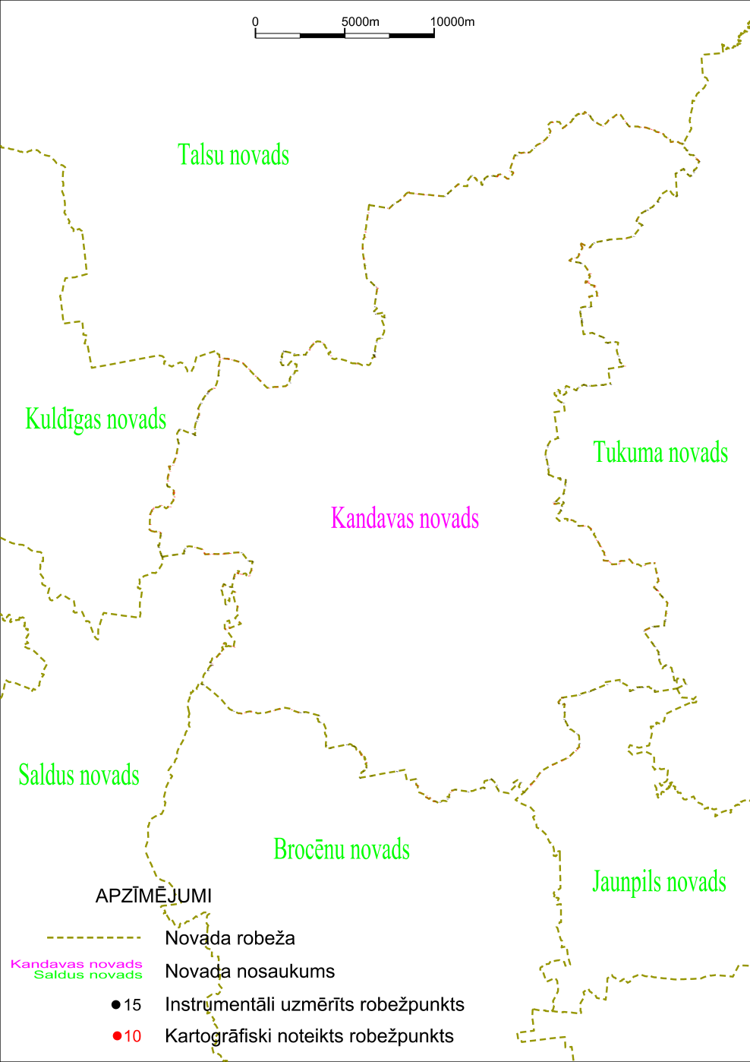

Tieslietu ministra vietā –
iekšlietu ministrs R.Kozlovskis

