108.pielikums
Ministru kabineta
2013.gada 19.marta
noteikumiem Nr.154

Tukuma novada administratīvās teritorijas robežas apraksts

2012.gada 1.oktobris
(robežas apraksta sagatavošanas datums)

Nr.  p.k. | Tās zemes vienības kadastra apzīmējums, pa kuru noteikta administratīvās teritorijas robeža | Robežojošās administratīvās teritorijas nosaukums
 | 90960020154 | Talsu novads
 | 90960020181 | Talsu novads
 | 90960020154 | Talsu novads
 | 90960020180 | Talsu novads
 | 90960010100 | Talsu novads
 | 90960010041 | Talsu novads
 | 90960010002 | Talsu novads
 | 90960010053 | Talsu novads
 | 90960010106 | Talsu novads
 | 90960010023 | Talsu novads
 | 90960010024 | Talsu novads
 | 90960010014 | Talsu novads
 | 90960010016 | Talsu novads
 | 90960010098 | Talsu novads  Mērsraga novads
 | 90960010104 | Mērsraga novads  Engures novads
 | 90960010098 | Engures novads
 | 90960010027 | Engures novads
 | 90960010106 | Engures novads
 | 90960010025 | Engures novads
 | 90960010099 | Engures novads
 | 90960010123 | Engures novads
 | 90960010099 | Engures novads
 | 90960010112 | Engures novads
 | 90960010099 | Engures novads
 | 90960010105 | Engures novads
 | 90960010101 | Engures novads
 | 90960010013 | Engures novads
 | 90960010101 | Engures novads
 | 90780010042 | Engures novads
 | 90780010050 | Engures novads
 | 90780010053 | Engures novads
 | 90780010094 | Engures novads
 | 90780010005 | Engures novads
 | 90780010004 | Engures novads
 | 90780010100 | Engures novads
 | 90780010036 | Engures novads
 | 90780010046 | Engures novads
 | 90780010025 | Engures novads
 | 90780010006 | Engures novads
 | 90780010079 | Engures novads
 | 90780010009 | Engures novads
 | 90780010008 | Engures novads
 | 90780010058 | Engures novads
 | 90780010090 | Engures novads
 | 90780010084 | Engures novads
 | 90780010011 | Engures novads
 | 90780010090 | Engures novads
 | 90780010015 | Engures novads
 | 90780010091 | Engures novads
 | 90780010064 | Engures novads
 | 90780010072 | Engures novads
 | 90780010016 | Engures novads
 | 90780010041 | Engures novads
 | 90780010068 | Engures novads
 | 90780010075 | Engures novads
 | 90780020047 | Engures novads
 | 90780020010 | Engures novads
 | 90780020075 | Engures novads
 | 90780020010 | Engures novads
 | 90780020008 | Engures novads
 | 90780020058 | Engures novads
 | 90780020047 | Engures novads
 | 90780020086 | Engures novads
 | 90780020076 | Engures novads
 | 90780020069 | Engures novads
 | 90780040133 | Engures novads
 | 90780040074 | Engures novads
 | 90780040034 | Engures novads
 | 90780040134 | Engures novads
 | 90780040030 | Engures novads
 | 90780080166 | Engures novads
 | 90780080029 | Engures novads
 | 90780080166 | Engures novads
 | 90780080062 | Engures novads
 | 90780080166 | Engures novads
 | 90780080037 | Engures novads
 | 90780080038 | Engures novads
 | 90780080037 | Engures novads
 | 90780080091 | Engures novads
 | 90780080034 | Engures novads
 | 90780080162 | Engures novads
 | 90780080039 | Engures novads
 | 90780080151 | Engures novads
 | 90780080040 | Engures novads
 | 90780080231 | Engures novads
 | 90780080040 | Engures novads
 | 90780080149 | Engures novads
 | 90780080163 | Engures novads
 | 90780080181 | Engures novads
 | 90840030150 | Engures novads
 | 90010010425 | Engures novads
 | 90010010452 | Engures novads
 | 90010010536 | Engures novads
 | 90010010452 | Engures novads
 | 90010010238 | Engures novads
 | 90010010540 | Engures novads
 | 90010010606 | Engures novads
 | 90010010542 | Engures novads
 | 90010010165 | Engures novads
 | 90010020502 | Engures novads
 | 90010020106 | Engures novads
 | 90010020101 | Engures novads
 | 90010020070 | Engures novads
 | 90010020093 | Engures novads
 | 90010020441 | Engures novads
 | 90010020054 | Engures novads
 | 90010020104 | Engures novads
 | 90010020106 | Engures novads
 | 90010020235 | Engures novads
 | 90010020405 | Engures novads
 | 90010020277 | Engures novads
 | 90010020299 | Engures novads
 | 90010020300 | Engures novads
 | 90010020386 | Engures novads
 | 90010020499 | Engures novads
 | 90010020317 | Engures novads
 | 90010020314 | Engures novads
 | 90010020430 | Engures novads
 | 90010020257 | Engures novads
 | 90010020509 | Engures novads
 | 90010020510 | Engures novads
 | 90010020457 | Engures novads
 | 90010020371 | Engures novads
 | 90010020347 | Engures novads
 | 90010020508 | Engures novads
 | 90010020075 | Engures novads
 | 90010020377 | Engures novads
 | 90010070373 | Engures novads
 | 90010070390 | Engures novads
 | 90010070384 | Engures novads
 | 90010070386 | Engures novads
 | 90010070352 | Engures novads
 | 90010070236 | Engures novads
 | 90010080137 | Engures novads
 | 90010080047 | Engures novads
 | 90010080375 | Engures novads
 | 90010080377 | Engures novads
 | 90010080407 | Engures novads
 | 90010080408 | Engures novads
 | 90010080306 | Engures novads
 | 90010080389 | Engures novads
 | 90010080300 | Engures novads
 | 90010080048 | Engures novads
 | 90010080014 | Engures novads
 | 90010080019 | Engures novads
 | 90010080390 | Engures novads
 | 90010080300 | Engures novads
 | 90010060041 | Engures novads
 | 90010060029 | Engures novads
 | 90010060021 | Engures novads
 | 90010060036 | Engures novads
 | 90010060020 | Engures novads
 | 90010060054 | Engures novads
 | 90010060067 | Engures novads
 | 90840090348 | Engures novads
 | 90840090347 | Engures novads
 | 90840090164 | Engures novads
 | 90840090352 | Engures novads
 | 90840090165 | Engures novads
 | 90840090382 | Engures novads
 | 90840090128 | Engures novads
 | 90840090127 | Engures novads
 | 90840090126 | Engures novads
 | 90460030027 | Engures novads
 | 90460030057 | Engures novads
 | 90460030029 | Engures novads
 | 90460030004 | Engures novads
 | 90800010035 | Engures novads
 | 90800010049 | Engures novads
 | 90800010067 | Engures novads
 | 90800010021 | Engures novads
 | 90800010082 | Engures novads
 | 90800010083 | Engures novads
 | 90800010064 | Engures novads
 | 90800010065 | Engures novads
 | 90800020114 | Engures novads
 | 90800030107 | Engures novads
 | 90800040068 | Engures novads
 | 90800050014 | Engures novads  Jūrmalas pilsēta
 | 90800050017 | Jūrmalas pilsēta  Babītes novads
 | 90800050024 | Babītes novads
 | 90800050011 | Babītes novads  Jelgavas novads
 | 90480030252 | Jelgavas novads
 | 90480030256 | Jelgavas novads
 | 90480030070 | Jelgavas novads
 | 90480030255 | Jelgavas novads  Dobeles novads
 | 90480030071 | Dobeles novads
 | 90480030255 | Dobeles novads
 | 90480030017 | Dobeles novads
 | 90480030134 | Dobeles novads
 | 90480030045 | Dobeles novads
 | 90480030006 | Dobeles novads
 | 90480030246 | Dobeles novads
 | 90480030125 | Dobeles novads
 | 90480030144 | Dobeles novads
 | 90480030343 | Dobeles novads
 | 90480030150 | Dobeles novads
 | 90480030225 | Dobeles novads
 | 90480030341 | Dobeles novads
 | 90480030044 | Dobeles novads
 | 90480030051 | Dobeles novads
 | 90480030222 | Dobeles novads
 | 90480030250 | Dobeles novads
 | 90480030135 | Dobeles novads
 | 90480030248 | Dobeles novads
 | 90480020010 | Dobeles novads
 | 90480020051 | Dobeles novads
 | 90480020023 | Dobeles novads
 | 90480020095 | Dobeles novads
 | 90480020009 | Dobeles novads
 | 90480020015 | Dobeles novads
 | 90480020001 | Dobeles novads
 | 90480020002 | Dobeles novads
 | 90480020101 | Dobeles novads
 | 90480020105 | Dobeles novads
 | 90480020017 | Dobeles novads
 | 90480010215 | Dobeles novads
 | 90480060017 | Dobeles novads
 | 90480060064 | Dobeles novads
 | 90480060019 | Dobeles novads
 | 90480060024 | Dobeles novads
 | 90480060016 | Dobeles novads
 | 90480060048 | Dobeles novads
 | 90480070008 | Dobeles novads
 | 90480070019 | Dobeles novads
 | 90480070021 | Dobeles novads
 | 90480070020 | Dobeles novads
 | 90480070010 | Dobeles novads
 | 90480070004 | Dobeles novads
 | 90480070007 | Dobeles novads
 | 90480070026 | Dobeles novads
 | 90480070025 | Dobeles novads
 | 90480070027 | Dobeles novads
 | 90480070014 | Dobeles novads
 | 90480070028 | Dobeles novads
 | 90480070039 | Dobeles novads
 | 90480050231 | Dobeles novads
 | 90480050014 | Dobeles novads
 | 90480050098 | Dobeles novads
 | 90480050038 | Dobeles novads
 | 90480050024 | Dobeles novads
 | 90480050086 | Dobeles novads
 | 90480050128 | Dobeles novads
 | 90480050011 | Dobeles novads
 | 90480050127 | Dobeles novads
 | 90480050170 | Dobeles novads
 | 90480050054 | Dobeles novads
 | 90480050049 | Dobeles novads
 | 90480050126 | Dobeles novads
 | 90480050026 | Dobeles novads
 | 90480040077 | Dobeles novads
 | 90480040104 | Dobeles novads
 | 90480040097 | Dobeles novads
 | 90480040038 | Dobeles novads
 | 90480040056 | Dobeles novads
 | 90480040121 | Dobeles novads
 | 90480040075 | Dobeles novads
 | 90480040121 | Dobeles novads
 | 90480040078 | Dobeles novads
 | 90480040120 | Dobeles novads
 | 90480040031 | Dobeles novads
 | 90480040070 | Dobeles novads
 | 90480040020 | Dobeles novads
 | 90480040104 | Dobeles novads
 | 90480040050 | Dobeles novads
 | 90480040042 | Dobeles novads
 | 90480040045 | Dobeles novads
 | 90480040008 | Dobeles novads
 | 90480040087 | Dobeles novads  Jaunpils novads
 | 90480040117 | Jaunpils novads
 | 90480040112 | Jaunpils novads
 | 90480040116 | Jaunpils novads
 | 90480040088 | Jaunpils novads
 | 90480040014 | Jaunpils novads
 | 90480040012 | Jaunpils novads
 | 90480040003 | Jaunpils novads
 | 90680020137 | Jaunpils novads
 | 90680020094 | Jaunpils novads
 | 90680020126 | Jaunpils novads
 | 90680020075 | Jaunpils novads
 | 90680020110 | Jaunpils novads
 | 90680020121 | Jaunpils novads
 | 90680020059 | Jaunpils novads
 | 90680020074 | Jaunpils novads
 | 90680020096 | Jaunpils novads
 | 90680020122 | Jaunpils novads
 | 90680020123 | Jaunpils novads
 | 90680020047 | Jaunpils novads
 | 90680020016 | Jaunpils novads
 | 90680020018 | Jaunpils novads
 | 90680020019 | Jaunpils novads
 | 90680020068 | Jaunpils novads
 | 90680020124 | Jaunpils novads
 | 90680020020 | Jaunpils novads
 | 90540050096 | Jaunpils novads
 | 90540050123 | Jaunpils novads
 | 90540050175 | Jaunpils novads
 | 90540050075 | Jaunpils novads
 | 90540050176 | Jaunpils novads
 | 90540050075 | Jaunpils novads
 | 90540050136 | Jaunpils novads
 | 90540050074 | Jaunpils novads
 | 90540050069 | Jaunpils novads
 | 90540050149 | Jaunpils novads
 | 90540050028 | Jaunpils novads
 | 90540050172 | Jaunpils novads
 | 90540050028 | Jaunpils novads
 | 90540050070 | Jaunpils novads
 | 90540050157 | Jaunpils novads
 | 90540050149 | Jaunpils novads
 | 90540050097 | Jaunpils novads
 | 90540050087 | Jaunpils novads
 | 90540050024 | Jaunpils novads
 | 90540050082 | Jaunpils novads
 | 90540050132 | Jaunpils novads
 | 90540050124 | Jaunpils novads
 | 90540050033 | Jaunpils novads
 | 90540050112 | Jaunpils novads
 | 90540050124 | Jaunpils novads
 | 90540030199 | Jaunpils novads
 | 90540030147 | Jaunpils novads
 | 90540030126 | Jaunpils novads
 | 90540030021 | Jaunpils novads
 | 90540030017 | Jaunpils novads
 | 90540030015 | Jaunpils novads
 | 90540030007 | Jaunpils novads
 | 90540030186 | Jaunpils novads
 | 90540030023 | Jaunpils novads
 | 90540030149 | Jaunpils novads
 | 90540030124 | Jaunpils novads
 | 90540030170 | Jaunpils novads
 | 90540030188 | Jaunpils novads
 | 90540030050 | Jaunpils novads
 | 90540030001 | Jaunpils novads
 | 90540030098 | Jaunpils novads  Kandavas novads
 | 90540030013 | Kandavas novads
 | 90540010150 | Kandavas novads
 | 90540010295 | Kandavas novads
 | 90540010151 | Kandavas novads
 | 90540010064 | Kandavas novads
 | 90540010054 | Kandavas novads
 | 90540010064 | Kandavas novads
 | 90540010158 | Kandavas novads
 | 90540010070 | Kandavas novads
 | 90540010101 | Kandavas novads
 | 90540010065 | Kandavas novads
 | 90540010047 | Kandavas novads
 | 90540010005 | Kandavas novads
 | 90540010175 | Kandavas novads
 | 90540010162 | Kandavas novads
 | 90540010144 | Kandavas novads
 | 90540010174 | Kandavas novads
 | 90540010053 | Kandavas novads
 | 90540010142 | Kandavas novads
 | 90540010231 | Kandavas novads
 | 90540010166 | Kandavas novads
 | 90540010138 | Kandavas novads
 | 90540010085 | Kandavas novads
 | 90540010140 | Kandavas novads
 | 90580070012 | Kandavas novads
 | 90580040150 | Kandavas novads
 | 90580040055 | Kandavas novads
 | 90580040054 | Kandavas novads
 | 90580040051 | Kandavas novads
 | 90580040151 | Kandavas novads
 | 90580040044 | Kandavas novads
 | 90580040052 | Kandavas novads
 | 90580040053 | Kandavas novads
 | 90580040143 | Kandavas novads
 | 90580040040 | Kandavas novads
 | 90580040029 | Kandavas novads
 | 90580040111 | Kandavas novads
 | 90580040039 | Kandavas novads
 | 90580040008 | Kandavas novads
 | 90580040088 | Kandavas novads
 | 90580010184 | Kandavas novads
 | 90580010154 | Kandavas novads
 | 90580010248 | Kandavas novads
 | 90580010226 | Kandavas novads
 | 90580010248 | Kandavas novads
 | 90580010044 | Kandavas novads
 | 90580010046 | Kandavas novads
 | 90580010075 | Kandavas novads
 | 90580010026 | Kandavas novads
 | 90580010194 | Kandavas novads
 | 90580010009 | Kandavas novads
 | 90580010287 | Kandavas novads
 | 90580010178 | Kandavas novads
 | 90580010186 | Kandavas novads
 | 90580010278 | Kandavas novads
 | 90580010074 | Kandavas novads
 | 90580010022 | Kandavas novads
 | 90580010258 | Kandavas novads
 | 90580010126 | Kandavas novads
 | 90580010206 | Kandavas novads
 | 90580010266 | Kandavas novads
 | 90580010024 | Kandavas novads
 | 90580010029 | Kandavas novads
 | 90580010002 | Kandavas novads
 | 90740090092 | Kandavas novads
 | 90740090027 | Kandavas novads
 | 90740070007 | Kandavas novads
 | 90740070068 | Kandavas novads
 | 90740070065 | Kandavas novads
 | 90740070074 | Kandavas novads
 | 90740070078 | Kandavas novads
 | 90740070067 | Kandavas novads
 | 90740070279 | Kandavas novads
 | 90740070010 | Kandavas novads
 | 90740070073 | Kandavas novads
 | 90740070035 | Kandavas novads
 | 90740070094 | Kandavas novads
 | 90740070079 | Kandavas novads
 | 90740070071 | Kandavas novads
 | 90740070034 | Kandavas novads
 | 90740070072 | Kandavas novads
 | 90740070029 | Kandavas novads
 | 90740070028 | Kandavas novads
 | 90740070030 | Kandavas novads
 | 90740070027 | Kandavas novads
 | 90740070083 | Kandavas novads
 | 90740040015 | Kandavas novads
 | 90740040005 | Kandavas novads
 | 90740040016 | Kandavas novads
 | 90740040089 | Kandavas novads
 | 90740040016 | Kandavas novads
 | 90740040165 | Kandavas novads
 | 90740040004 | Kandavas novads
 | 90740040021 | Kandavas novads
 | 90740040174 | Kandavas novads
 | 90740040029 | Kandavas novads
 | 90740040174 | Kandavas novads
 | 90740040045 | Kandavas novads
 | 90740040082 | Kandavas novads
 | 90740040045 | Kandavas novads
 | 90740040157 | Kandavas novads
 | 90740040017 | Kandavas novads
 | 90740040049 | Kandavas novads
 | 90740040081 | Kandavas novads
 | 90740040011 | Kandavas novads
 | 90740010005 | Kandavas novads
 | 90740010046 | Kandavas novads
 | 90740010037 | Kandavas novads
 | 90740010042 | Kandavas novads
 | 90740010041 | Kandavas novads
 | 90740010068 | Kandavas novads
 | 90740010036 | Kandavas novads
 | 90740010031 | Kandavas novads
 | 90740010020 | Kandavas novads
 | 90740010032 | Kandavas novads
 | 90960020030 | Kandavas novads
 | 90960020081 | Kandavas novads
 | 90960020059 | Kandavas novads
 | 90960020081 | Kandavas novads
 | 90960020080 | Kandavas novads
 | 90960020049 | Kandavas novads
 | 90960020163 | Kandavas novads
 | 90960020191 | Kandavas novads
 | 90960020044 | Kandavas novads
 | 90960020194 | Kandavas novads  Talsu novads
 | 90960020195 | Talsu novads
 | 90960020023 | Talsu novads
 | 90960020028 | Talsu novads
 | 90960020139 | Talsu novads
 | 90960020014 | Talsu novads
 | 90960020165 | Talsu novads
 | 90960020140 | Talsu novads
 | 90960020015 | Talsu novads
 | 90960020063 | Talsu novads
 | 90960020072 | Talsu novads
 | 90960020183 | Talsu novads
 | 90960020153 | Talsu novads
 | 90960020167 | Talsu novads

Tukuma novada administratīvās teritorijas robežas karte

2012.gada 1.oktobris
(robežas apraksta sagatavošanas datums)

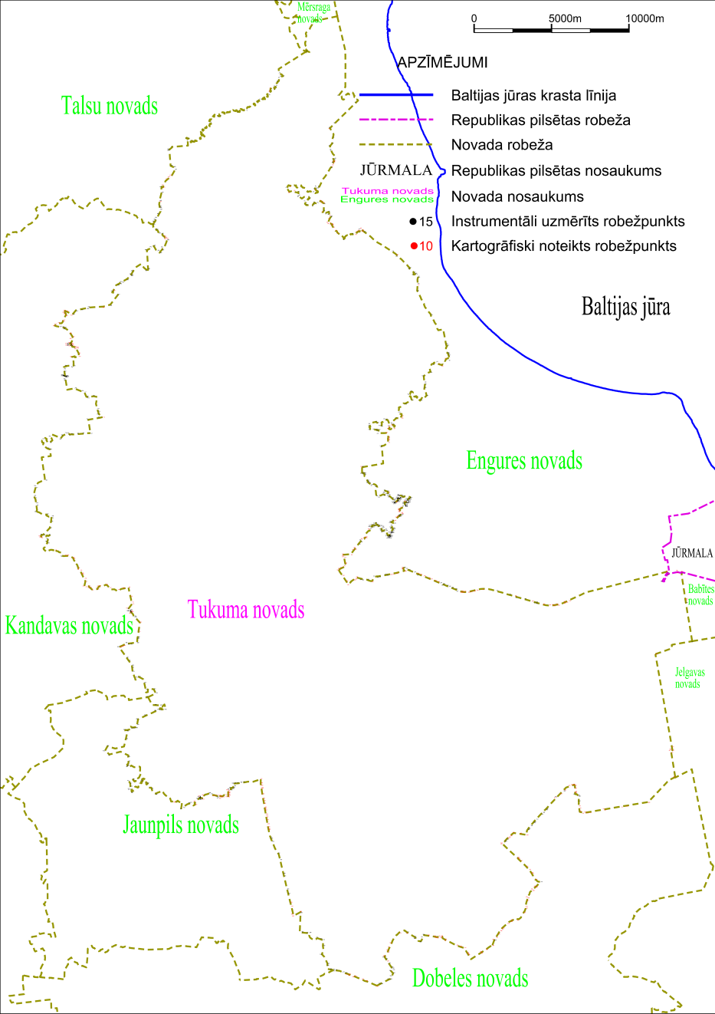

Tieslietu ministra vietā –
iekšlietu ministrs R.Kozlovskis

